

WEB SCRIPTING

CSE – 220 QUARTER V



September 23, 2020

M.Sathishkumar

E0119052

**Challenge 1:**

Assigning a variable myVar = 10 and make in immutable

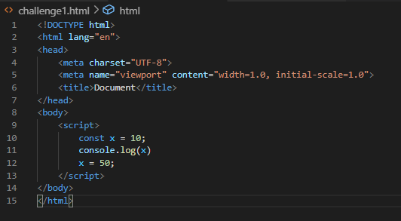

Output:

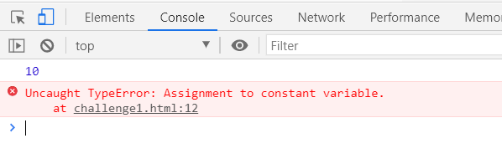

**Challenge 2:**

Assigning four variable and print them

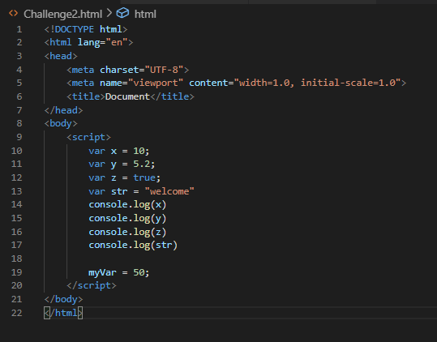

Output:

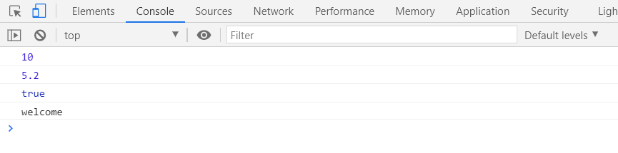

**Challenge 3:**

Create two lists and print them

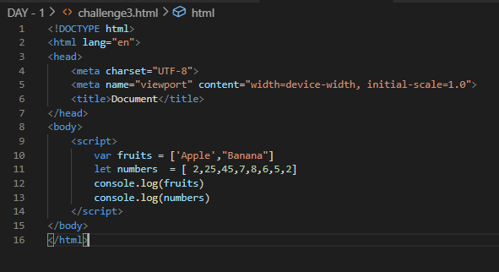

Output:

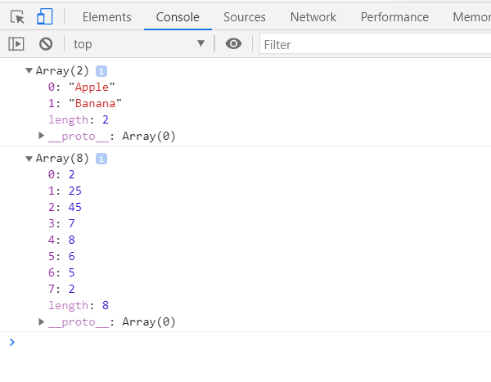

**Challenge 4:**

Create two lists and find length of lists

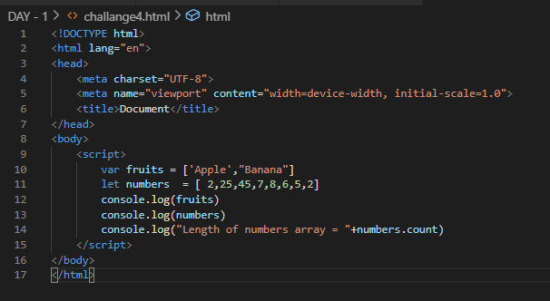

Output:

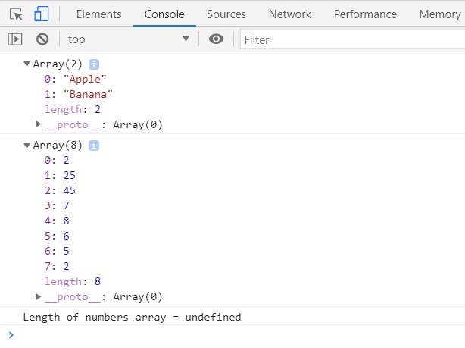

**Challenge 5:**

Creating objects in two ways

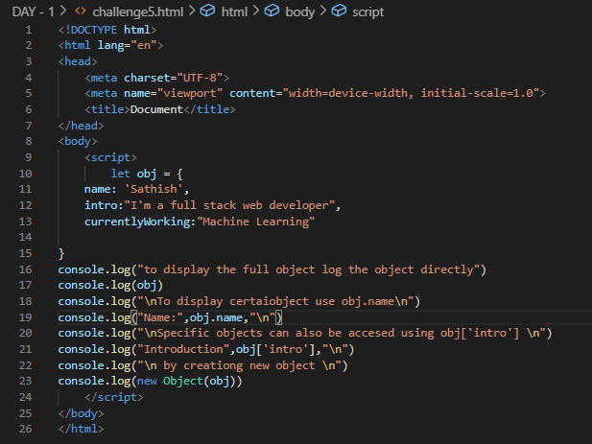

Output:

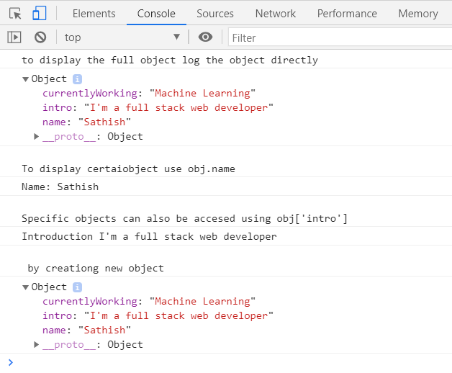

**Challenge 6:**

Create two lists and print them

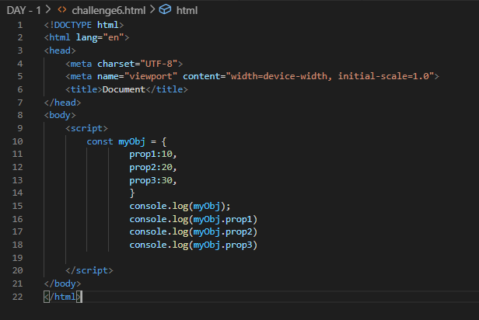

Output:

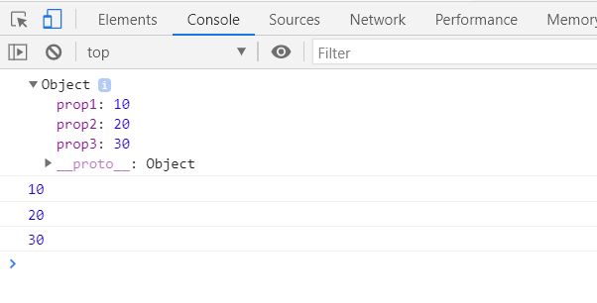

**Challenge 7:**

Altering attribute of an object

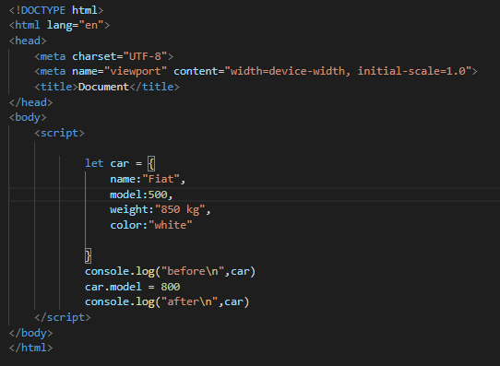

Output:

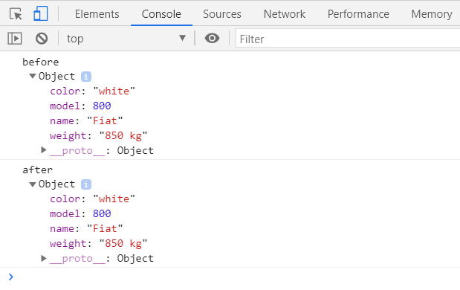

**Challenge 8:**

Inserting a object into another object

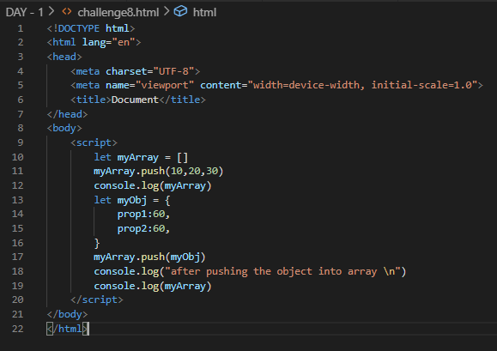

Output:

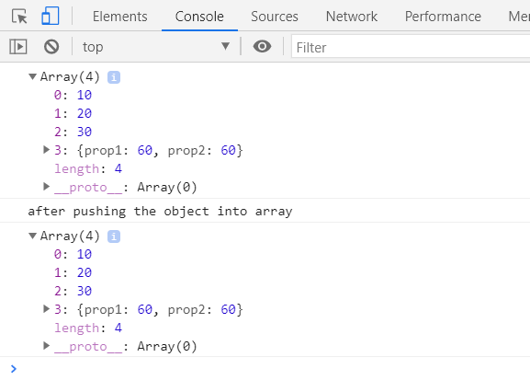

**Challenge 9:**

Mark and John are trying to compare their BMI (Body Mass Index), which is calculated using the formula: BMI = mass / height^2 = mass / (height * height). (mass in kg and height in meter).

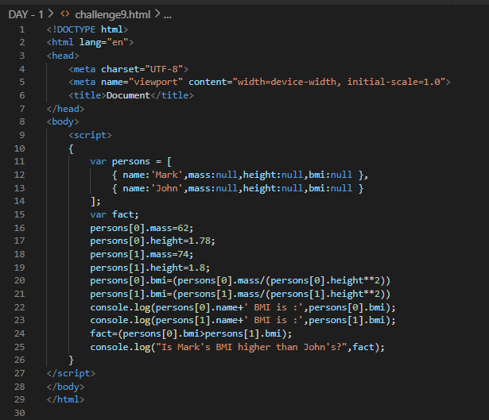

Output:

